Source 1: Topography of North Dakota
Directions: Label the following terms on the map below:
*Missouri Escarpment *Missouri Plateau *Central Lowlands *Great Plains
*Upper River Basin *Drift Prairie *Red River Valley

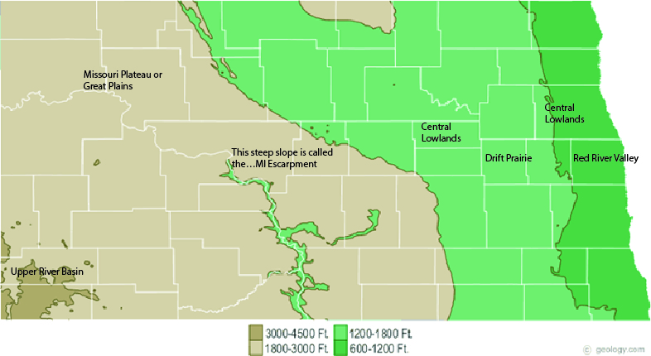

Source 2: Climate of North Dakota
Read about the climate of North Dakota and draw a picture in the box below. Then, choose three words to describe your picture and the climate of North Dakota.
Illustrate North Dakota Climate:  Student specific answers! | Three Words to Describe North Dakota Climate:

Source 3: East to West Migration
Many of the Plains Indian tribes originally were from the Great Lakes area of Minnesota. Extreme weather changes and conflicts with other tribes led to westward migration into North Dakota.
Step One: Using your knowledge of North Dakota Topography and weather, predict whether the statements below describe life in Minnesota or North Dakota.
Step Two: Then check your predications using the reading titled “East to West Migration”.
*Expert canoe-men *Expert horsemen *Wore hard sole moccasins *wore soft-soled moccasins

*ate fish and wild rice *ate buffalo meat and tipsin roots *more nomadic *more sedentary

*used long bows *used short bows *slept in hide tipis *built bark covered wigwams

*made sugar from box elder sap *boiled maple sap into sugar *Lived in one place year-round

*traveled to follow herds of animals and seasons

Forest Life in Minnesota | Plains Life in North Dakota
*Expert canoe-men *wore soft-soled moccasins  *ate fish and wild *more sedentary  *used long bows *built bark covered wigwams  *boiled maple sap into sugar  *Lived in one place year-round | *Expert horsemen *Wore hard sole moccasins  *ate buffalo meat and tipsin roots *more nomadic  *used short bows *slept in hide  *made sugar from box elder  *traveled to follow herds of animals and seasons

